Welcome to the Welsh Athletics Officials Step challenge

Not sure where to start? Why not begin with a weekly personal challenge…. can you climb Wales’ highest mountain Snowdon in a week? Did you know Snowdon has 6 different routes?
- The Llanberis Path (9 miles/14.5 km)

- The Miners’ Track (8 miles/13 km)

- The Pyg Track (7 miles/11 km)

- The Rhyd Ddu Path (8.5 miles/12km)

- The Watkin Path (8 miles/13km)

- Snowdon Ranger Path (8 miles/13km)

If you don’t get to the finish point within a week period don’t worry, just keep working at it.

How to measure your steps?
- Traditional pedometer
- Free apps
- Smart phone pedometer
- Smart watches

Wear your pedometer/phone/watch daily and see how many steps you are doing as part of your normal routine.

There are a number of free apps available that record your steps just as a pedometer. If you have a smart phone check out what’s available in your app store and give some of them a go to see which suit you best. Other mobile devices often have a step counter built in.

Most basic pedometers clip to your belt or your waistband. To record your steps accurately the pedometer needs to be in a vertical position and not tilting. A good place to attach it to keep it vertical is at the side or the back. For accuracy

try to use a motion pedometer or accelerometer rather than a coiled spring pedometer. These can be worn anywhere on the body including in your pocket or in a bag but don’t cheat and put it on the dog!

- Record how many steps you take in your first week using your pedometer walk as often as you would normally.

- Decide on some milestones and write them onto your log sheet on page 4.

- Keep a record of your steps, use the conversion chart on page 4 to work out the miles you walked each week. When you reach your milestone mark it on the chart. Using the you can calculate your total step count and indicate the distance you have walked.

Here are some ideas of distance milestones:

13.1 miles - Cardiff half marathon
68 miles - Chester/Flintshire > Conwy/Gwynedd border
68 miles - Pembrokeshire > Carmarthenshire/Swansea border
71 miles - Swansea > Neath Port Talbot/Bridgend border
72 miles - Powys > Pembroke border
97 miles - Neath Port Talbot / Bridgend > Chepstow
129 Miles - Menai Bridge > Llanfairpwll
180 miles - Conwy/Gwynedd > Powys border
180 miles - Ceredigion > Carmarthenshire border
870 miles - Walk the Wales coast path

Be a part of the virtual leader board

For this virtual step challenge, I have made a excel spreadsheet on Microsoft Teams for individuals to record steps. To be a part of this challenge please respond to my newsletter I will invite you to the Microsoft Team ‘Step Challenge Officials’. Once you have joined, you will be able to see the live document that each official participating can add your total steps per day. On an individual basis the virtual official leader board track the Top 10 individual officials.

Also, I will incorporate a team element to the leader board made by separating results by the four regions. As a region if you cover on average 20 miles a day for 6 weeks you will reach 870 miles which is the equivalent of virtually walk around the Wales Coastal Path, that’s about one million seven hundred and forty thousand steps!

Please refrain from going outside unnecessarily follow the government health guidelines. We encourage you to take part in this step challenge inside your home or in the garden.

6 week personal log to get you started

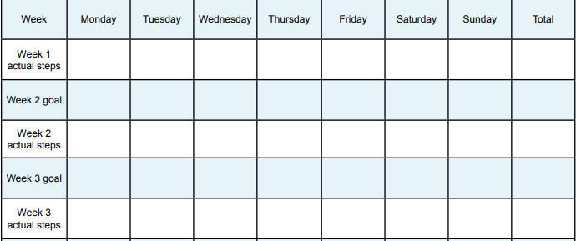

Steps and distances quick conversion chart
On average 2200 steps = 1 mile
